[](http://www.warrenpointfeis.com/)

**GUIDE FOR ON-LINE ENTRIES**

Step 1: Please select a category

* Speech and Drama
* Music
* Traditional Music

Step 2: Please select a class. You may need to select a sub category in order to see your class.

These may be listed in

* Private
* Primary School
* Drama

Step 3: Click the button Book Now

Step 4: A pop up window will appear. Please see graphic below

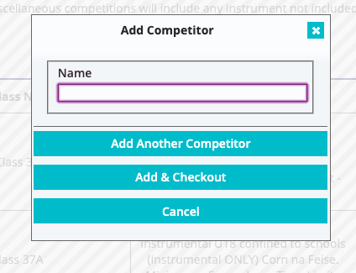

Step 5: Add child’s name, if you need to add more than one child click add another competitor.

Step 6: Repeat step 5 until you have all the children added to that class. On the last child, click the add & checkout button.

Step 7: You will see a list like below, check the details are correct. If not, you can delete and re-add.

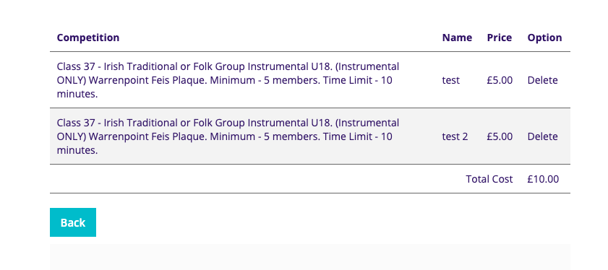

Step 8: If you have more classes to add please repeat steps 1 to 8

Step 9: When you have all children added to all your classes please fill in the form and proceed to payment form. Example below

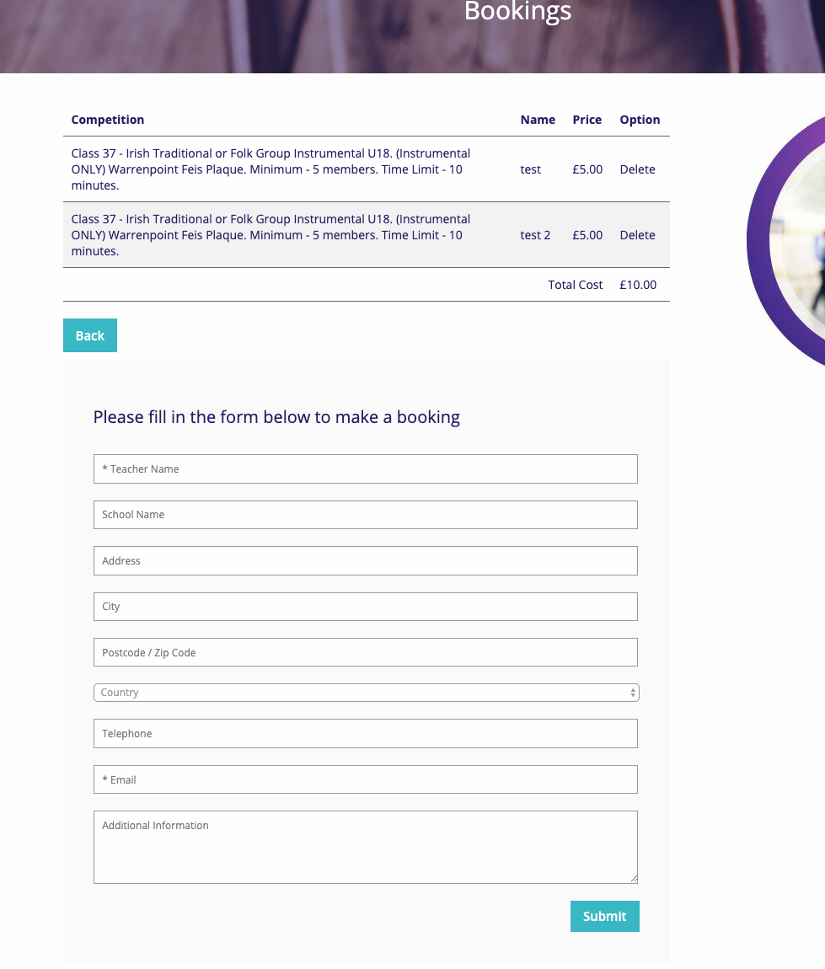

Step 10: Please note payments are made via PayPal – you do not need a PayPal account. You can pay by debit or credit card, see image below.

