Smash it Cricket Programme
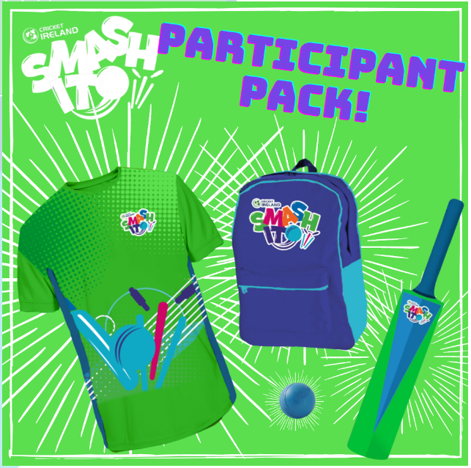
With thanks from an IEF grant we are very lucky to have Harry Lockhart Community Coach from Northern Cricket Union to be joining us again this week for a new programme for children aged 5-9 years old called Smash It.

Smash It is for girls and boys aged 5 – 9 years and is all about kids being active, making friends and having fun in an inclusive and safe environment. Smash It aims to get children excited about cricket through discovery and play, learning fundamental movement skills needed for batting, bowling, fielding and wicket-keeping. The programme is suitable for all children new to cricket and sport as the sessions are designed to teach the basic skills of the game. Every child will receive a certificate that logs their achievements as they learn each new skill.
- Movement – Keeping active through the ABC’S of movement
- Batting – Hitting lots of balls
- Throwing – underarm and overarm
- Catching – small and large balls
- Bowling – overarm & underarm
- Teamwork – fun games with friends
- Smashing Fun – respecting others

Smash It sessions are delivered by trained Club Activators and participants will receive a Smash It t-shirt, backpack, bat and ball once the school registers!

The Programme takes place in school and begins this Friday 23rd February and every Friday for 6 weeks with P2 from 9.45-10.30 and 10.30-11.15 with P3. The last session for P2&3 will be 12th April.

P4&5 lessons begin April19th for 6 weeks ending on 24th May same timings as above and on a Friday.
The children involved should come to school in their school PE kit.

