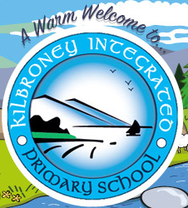

10 Reasons to choose Kilbroney Integrated Primary School Rostrevor
- Grounds
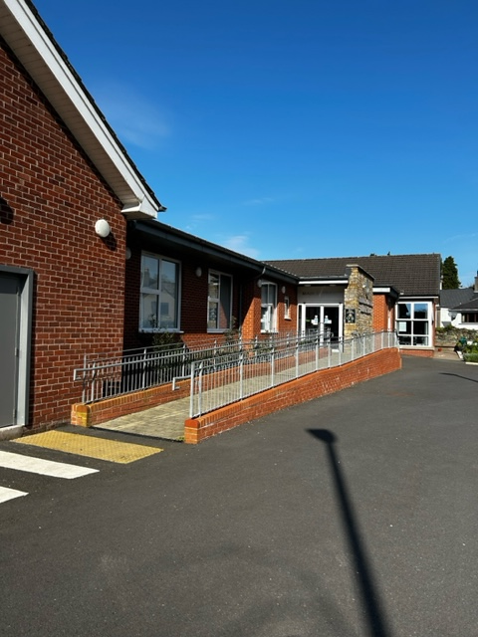
We have masses of space and we know how to use it! Our playground is enclosed by an ancient and beautiful stone wall and the front of the school overlooks the majestic Kilbroney Park and Slieve Martin part of the Mourne Mountains which we use as an outdoor classroom throughout the school year! Both the school grounds and Kilbroney Park provide lots of room for playing and learning.

- Community Garden and Play grounds
We have our own school Community Garden at the front of the school which is open to the wider community every Saturday morning from 11am to 1pm.
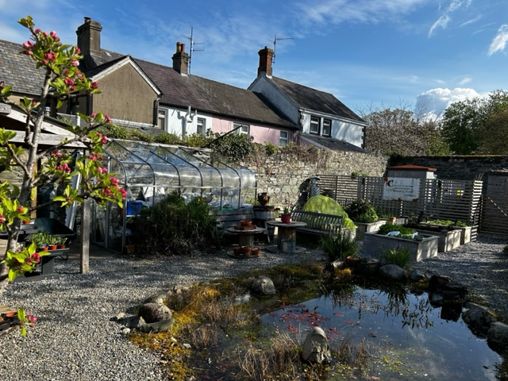
Our pond features a Japanese style garden and provides plenty of opportunities for exploring nature and art, as well as enjoying the peaceful surroundings whilst doing some work at the picnic tables. Our ECO schools club work away in the garden once a week planting varieties of plants and herbs. We even have our own plant sale once or twice per year. In our Greenhouse the children learn to how to grow plants, fruits and vegetables which they can later cook. At our community garden on Saturday mornings, the children can work with their siblings and parents to grow their own food.
We have a wonderful outdoor play area with lots of different resources which includes outdoor bikes and scooters, covered sand and water play, construction materials, playground markings and dedicated football area for the Year 1-3 children. For Year 4-7 there is a dedicated football area plus a fabulous forest play space to explore.
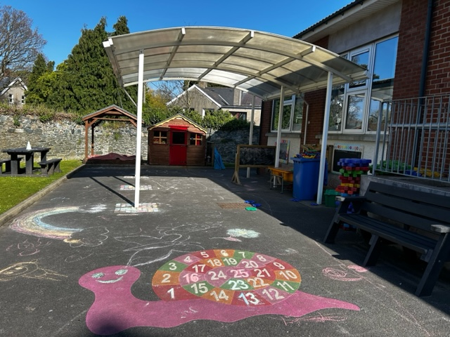
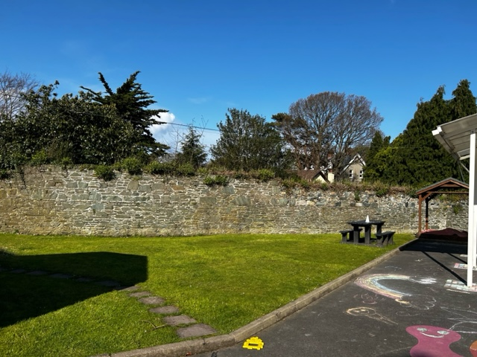
KS1 Play area

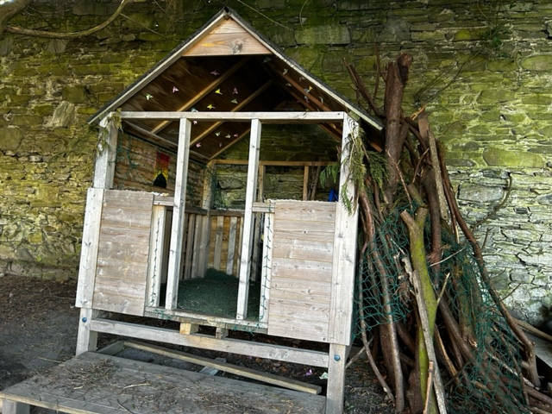
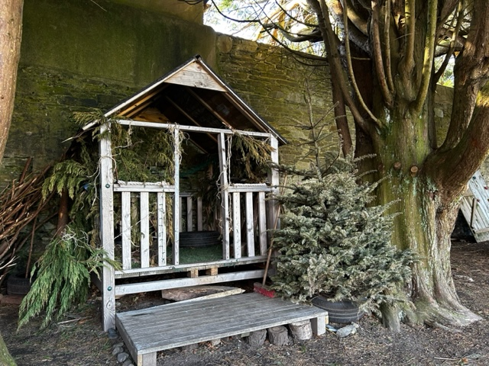
KS2 play area and forest play area
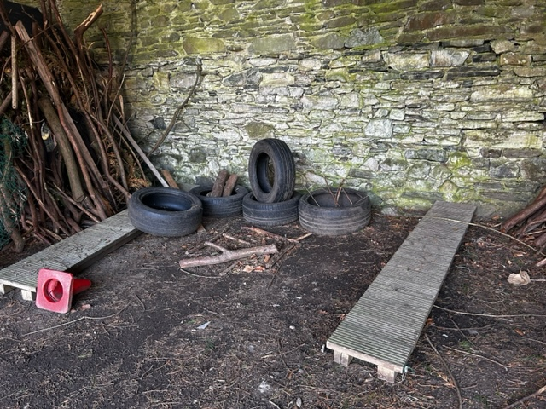
The forest garden provides the inspiration for a lot of numeracy and literacy tasks and at one end there is a sensory garden with a fire pit area where we can read stories, be creative and perform dramas.

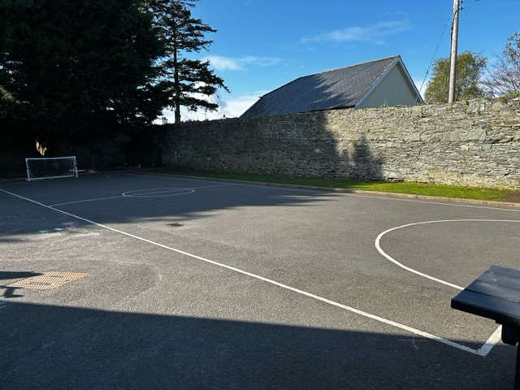
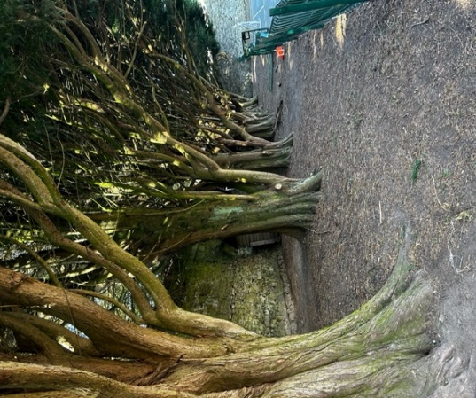
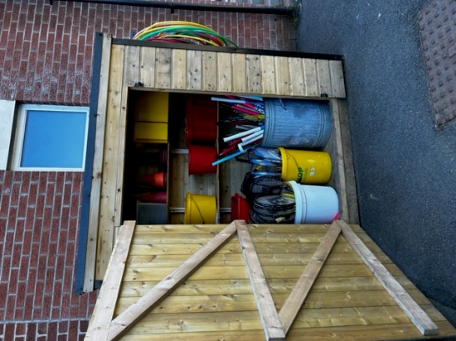
KS2 GAMES STORE
3 The Atmosphere
Everyone who visits our school comment on the warm and welcoming atmosphere. This is the special secret behind it; all our staff and pupils are happy to be here, and we just love to have visitors! At Kilbroney IPS, we seek to make everyone feel valued and part of our school community including children, staff, parents and grandparents. The impact of this approach can be seen through our happy children who love to learn, safe in the knowledge that both home and school are working together in their best interests.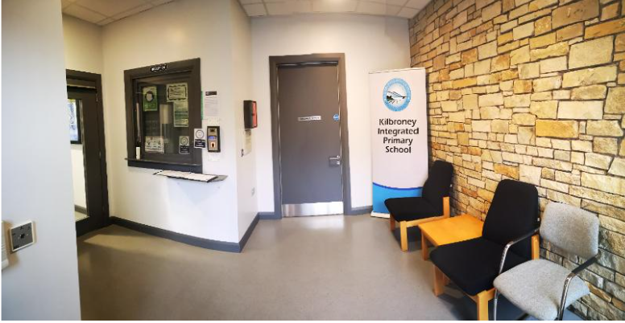

- Integration
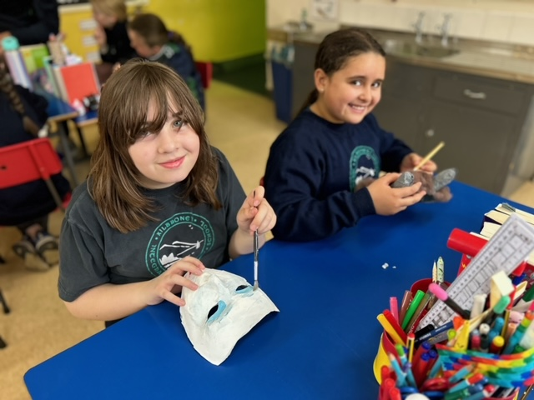
Our integrated ethos is at the heart of everything we do. It’s about much more than seeking diversity through our admissions criteria. It is about valuing and respecting people with different beliefs, cultures, socio-economic backgrounds, genders, ability levels, races, and ethnicities than our own. Our children learn not only about their own faiths but those of other world religions and the beliefs of those with no faith. Our children from a Catholic background have the opportunity to receive sacramental preparation through St Mary’s Star of the Sea, Parish Church. We also enjoy strong links with Kilbroney Parish Church and other local religious groups. We teach our children, not just to tolerate people who are different to themselves, but to explore and celebrate their similarities and differences. By the time our children move on to either Shimna Integrated College or other local Post-Primary schools, we are confident that they are well prepared to be excellent contributors to society.
5. High Quality Teaching and Learning
We are fortunate to have an experienced, talented, and dedicated teaching staff. Our key strength is the ability of our staff to take the requirements of the Northern Ireland curriculum and use innovative, creative and engaging teaching methods to help each child reach their full potential. We cater for pupils of all abilities, with both outstanding learning support, a highly skilled and experienced SENCO and the ability to challenge those children who are performing at a high level. Our approach is underpinned by robust tracking of each child’s progress at an individual level as they move through the school.
6. Communication
Communication with parents and families is extremely important to us here in Kilbroney. We know that your child’s experience at school will be more positive when we work together.
Each class have ‘Seesaw’ and the school’s website, which teachers can use to send messages to parents and to share children’s work, educational links and homework. We have a very active Facebook page which allows us to keep parents, grandparents and members of the school community up to date on the exciting things going on in the school. In addition, our school website provides useful information for both prospective and existing parents, including access to Schools NI app used to communicate whole school messages. We pride ourselves on being friendly and approachable so that parents can get in touch any time to discuss any issues which they want to raise. https://www.kilbroneyips.org.uk/home/

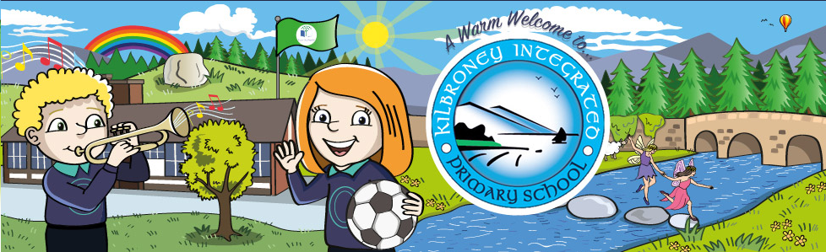

7. Pupil Voice
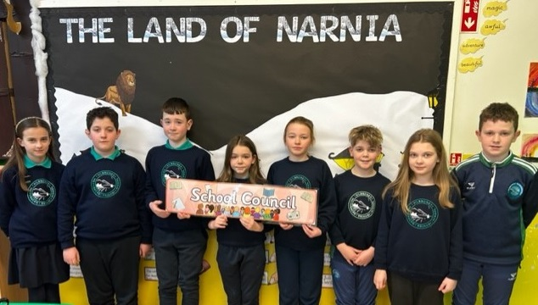
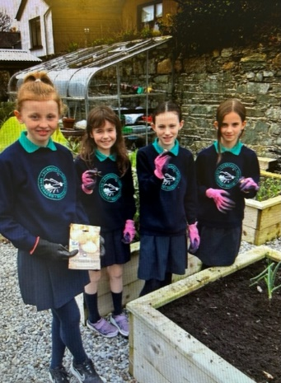
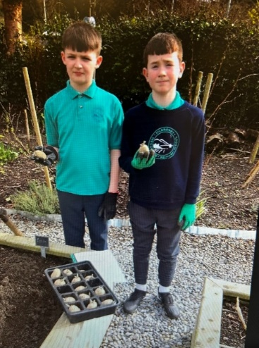
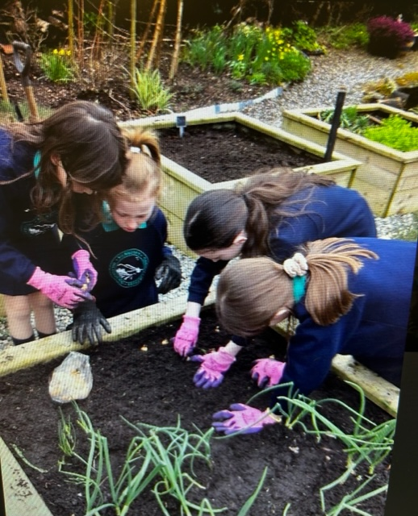
We empower our children by giving them a say in matters which affect them. We have a vibrant School Council with elected representatives who make decisions on school events, fundraising, purchasing new equipment and even contribute to school and community events. Children also have a say in the classroom where they help plan their topics and decide which activities they would like to do. In addition, our children have the opportunity to contribute to school life through the work of our Green Team who lead whole school initiatives working towards the awarding of our Eco-Schools status. Our Digital Leaders not only assist with trouble-shooting IT issues around the school but take suggestions from their peers about how the school could invest to improve our technology provision.

8. Extra-Curricular Activities
This year we really do have something for everyone. Over the years we have been able to offer jumping clay, netball, Football, Basketball, Gaelic Football, Tag Rugby, cookery, Tin Whistle, Hand Bells, Gardening Club, Arts and Crafts, Cycling Proficiency to name but a few. If you are interested in music, we have a very active choir who perform at many events throughout the year both in school and in the wider community. We also have an ensemble and traditional music group who regularly perform for us all. Normally, during the school day children from Year 4 onwards can avail of violin, woodwind, brass and other instruments on offer from the EA music service.
9 Up-To-Date
As a school we pride ourselves on being forward thinking and preparing our pupils for the real world. This is evident in the various facilities we have in our school. In addition to a well-equipped computer suite, each class has access to their own set of ipads which we use for educational games, film-making, research and recording our work in different ways. Every class will have a new touch screen interactive whiteboard by September 2023.
10.The Experience
Every school in Northern Ireland follow the same curriculum. Every child will be taught the same basic content no matter where they go to school, but at Kilbroney IPS we believe that it is the experiences they have whilst learning which will shape the adults they become and we are committed to ensuring that every child has the best possible experience. We want our pupils to be engaged, excited and motivated as that is when the real learning happens.
More about Kilbroney Park
Kilbroney Park Forest features riverside walks and an arboretum. There is a two-mile forest drive which showcases panoramic views over Carlingford Lough. There is also a Play Park with children's play area and tennis courts, an Information area and a café all on site.
The forest drive leads to a car park from where walkers have the opportunity to climb to Cloughmore, 'the big stone', a 30ton erratic, which sits at approx 1000ft above Rostrevor. Geologists explain its presence here as having been deposited during the ice age. However, local folklore claims it was thrown here by Finn Mac Cool during a fight with a Scottish Giant. During the same battle, the Scottish Giant allegedly tore out a handful of earth and flung it back at Finn, it missed and landed in the sea. We now know that area as the Isle of Man and the divot he made, filled up with water and became Lough Neagh.
Rostrevor Oak wood is a relic of a much larger forest. The woodland contains Oak, Ash, Sycamore, Hazel to name but a few. The Kilbroney Tree Trail will guide walkers through Kilbroney Park. The trail is not waymarked, each tree highlighted on the trail has a number and a plaque adjacent to the tree.

The Narnia Trail
This walk starts and finishes within Kilbroney Park and brings to life the Chronicles of Narnia with a number of features along the route. The trail is entered, like the magical world of Narnia itself, through a ‘Wardrobe Door’, beyond which lies a land filled with strange and intriguing creatures. Enter at your peril, as the White Witch has put a curse on the land. It is always winter and never Christmas – and she can turn you into stone. Be warned, don’t eat any “enchanted” Turkish Delight! Other features along the way include ‘The Lamp Post’, ‘The Beaver’s House’ and ‘Aslan’s Table’. These features offer many opportunities to interact and take photos/selfies.
“That part of Rostrevor which overlooks Carlingford Lough is my idea of Narnia” (CS Lewis)
This family trail seeks to capture the imagination of children of all ages.

Fairy Glen
The Fairy Glen walk provides varied scenery from gentle riverside to scenic parkland and woodland. The Fairy Glen is located on the left immediately after the bridge beside the entrance to Kilbroney Park and is opposite the school.

